***Cars Portal***

***(Web Application)***

**Submitted By: Supervised By:**

Zalle Hussain Mam Zainb Safdar

MCS-19-48

*Department of Computer Science*

*University Of Sahiwal*





Abstract: This is documentation about the Car Portal.

***Abstract***

The main objective of this project is to create an **Car Portal** that allows users to search Car based on category, name and other things. The selected Car are displayed, and the user can see their Cars online . Using this Website, the user can see details the Car online instead of going out to a Online ‘**Car Portal’** and wasting time.

‘**Car Portal (Web Application)**’ is an online web application where the customer can search the Car online. Through a web browser the customers can search for a Car by its Company, Model or Horace power . The user can login using his account details or new customers can set up an account very quickly. They should give the details of their name, contact number and E-mail address. A customer can, create, sign in to his account, place items into a car and Book the Car. The Administrator will have additional functionality when compared to the common user. He can add, delete and update the Car details, Car categories, member information and also confirm a placed Booking. After all, this Website is error free. Any user can use this website friendly.

***ACKNOWLEDGEMENT***

Praise to Allah Almighty, Lord of the worlds, the Merciful and the Beneficent, who gave us strength, thoughts and co-operative people to enable us to accomplish this goal and fulfill the required functionalities.

This was all not possible without the guidance, continuous appreciation and moral support by “**Dr.Shafiq”**. He was always there whenever we need her help and ideas. We are really thankful to her who made our concepts clearer.

At last, we would like to acknowledge all of the assistance and contributions of ‘**University Of Sahiwal**’ for supporting us with all that is needed starting from the books, and ending with the full care that it is providing us with, to help us to be professionals in the field of Information Technology.

***Declaration***

I do hereby declare that this project report has been prepared by me under the supervisor of **Mam Zainb Safdar** Department of Computer Science University of Sahiwal, for the partial fulfillment of the requirement for the MCS degree from the Department of Computer Science and Engineering at University of Sahiwal. I’m also declaring that this project report is original in nature and has not been submitted elsewhere.

Signature of Candidate

………………….

**Zalle Hussain**

**MCS-19-50**

*Department of Computer Science*

*University of Sahiwal, Sahiwal*

***CERTIFICATE OF APPROVAL***

It is to certify that the final year project of **MCS**  **“Online Car Portal** (A web application)**”** was developed by **Zalle Hussain** under the supervision of “**Mam Zainb Safdar**” and that in her opinion, it is in scope, fully adequacy and quality of the degree of Bachelors of Science in Computer Sciences.

**Supervisor External Examiner**

Zainb Safdar Name: _____________________

HOD (Computer Sciences) Designation:________________

Department of Computer Science Signature:­­­­__________________

______________________________ ____________________________

**Head of Department**

Dr. Shafiq Hussain

Department of Computer Science

__________________________________________

**CONTENTS**

|  |  |  |  |
| --- | --- | --- | --- |
| **Chapter-1: Introduction** | | | 1-5 |
| 1.1 | Overview | | 1-2 |
| 1.2 | Purpose and Motivation | | 2 |
| 1.3 | Project Overview | | 2-4 |
| 1.4 | Objective of the Project | | 4 |
| 1.5 | Facilities | | 4 |
|  | 1.5.1 | Facilities to be provided to the system administrator | 5 |
|  | 1.5.2 Facilities to be provided to the registered user | | 5 |
|  | 1.5.3 | Facilities to be provided to the Guest user | 5 |
| **Chapter-2: Technology Review and Methodology** | | | 6-16 |
|  | 2.1.1 | HTML | 7 |
|  | 2.1.2 | CSS | 7-8 |
|  | 2.1.3 | Bootstrap | 8 |
|  | 2.1.4 | jQuery | 8-9 |
|  | 2.1.5 | PHP | 9A |
|  | 2.1.6 | MySQL | 10 |
|  |
|  |  |  |  |

|  |  |  |  |
| --- | --- | --- | --- |
| 2.2 | Methodology | |  |
|  | 2.2.1 Developing the crucial functionalities: | | 12 |
|  | 2.2.2 Facilitating the user for allowing them access in the system | | 13 |
|  | 2.2.3 Developing the report generation and analytical functionalities | | 13 |
|  | 2.2.4 | Use of waterfall method | 14-16 |
|  | 2.2.5 | Adopted Methodology | 16A |
| **Chapter-3: System Analysis** | | | 17-31 |
| 3.1 | Schema | | 17 |
| 3.2 | Primary Key | | 17 |
| 3.3 | Foreign Key | | 17 |
| 3.4 | Data Dictionary | | 18 |
| 3.5 | Description of data objects in database table | | 19-24 |
| 3.6 | Entity Relationship Diagram (E-R diagram) | | 25 |
| 3.7 | Use case Diagram | | 26 |
| 3.8 | Sequence Diagram | | 27 |
| 3.9 | Class Diagram | | 28 |
| 3.10 | DFD For User Registration | | 29-31 |
| 3.11 DFD For User View | | | 30 |
| * 1. DFD For Book Store Order | | | 30 |
| 3.13 Planning & Scheduling 31 | | |  |
| **Chapter-4: Testing** | | | 32-38 |
| 4.1 | Featured to be tested | | 32 |
| 4.2 | Test Cases | | 32 |
|  | 4.2.1 | User | 33-34 |
|  | 4.2.2 | Admin | 34-35 |
| 4.3 | Approach | | 37-38 |
| 4.4 | Pass/Fail Criteria | | 38 |

|  |  |  |  |  |
| --- | --- | --- | --- | --- |
| **Chapter-5: Graphical User Interface** | | | | 39-46 |
| 5.1 | Organization of the Template | | | 39 |
|  | 5.1.1 | Home Page |  | 39 |
|  | 5.1.2 | Registering Users | | 40 |
|  | 5.1.3 | Cars Details | | 40 |
|  | 5.1.4 | Search Box |  | 41 |
|  | 5.1.5 | User’s Order | | 42 |
|  |  | 5.1.5.1 | Car | 43 |
|  |  | 5.1.5.2 | Cars table | 44 |
| 4 | 5.1.6 | User’s Invoice | | 45 |
|  | 5.1.7 | Admin table | | 44 |
| 5.2 | Admin Login Page | |  | 45 |
|  | 5.2.1 | Admin Home Page | | 45 |
|  | 5.2.2 | Manage Status | | 46 |
| **Chapter-6: Conclusion** | | |  | 46-49 |
| 6.1 | System Limitation | |  | 47 |
| 6.2 | Prospective Future Development | | | 47 |
| 6.3 | Conclusion | |  | 48 |

**References: 49**

**CHAPTER 1**

**INTRODUCTION**

**1.1 Overview**

The modern world is surrounded by the technology and internet is the biggest invention of the world which is a worldwide system of computer networks. In the network users at any computer can communicate with the other if they have permission to get information from any other computer. Today hundreds of millions of people worldwide are using internet and most widely used part of the internet is the World Wide Web (www). It is basically a system of internet servers that support specially formatted documents which is formatted in a markup language called Hyper Text Markup Language (HTML) that supports links to other documents, as well as graphics, audio, and video files. Web page is a document commonly written in Hyper Text Markup Language (HTML) that is accessible through the internet or other network using an internet browser by entering a URL address and many contain text, graphics and hyperlinks to other web pages and files. A website contains thousands of different pages including the web pages. The people can access the website in any places using the internet. So that the businessman and consumers are selling, showing, marketing their products making the attractive website and deliver the products as early as possible. Any type of business or commercial transactions that involves the transfer of information across the internet is called Electronic Commerce or Portal. It allows consumers to electrically exchange goods and services with no barriers of time or distance.

[Booking cart software](http://www.networksolutions.com/e-commerce/index.jsp) is an operating system used to allow consumers to purchase goods and or services, track customers, and tie together all aspects of Portal into one cohesive whole. A user can entered an online store, see the product that fulfill their demand and select it in the cart for the next step.

To complete the order they need to checkout and complete the transaction by providing payment information.

1

Online Car Portal is an Portal site where the user can see the Cars, select the Car and book it.

**1.2 Purpose and Motivation**

The main objective of this project is to create an Online Car Portal that allows users to search based on category, Model and Hose Power the Car. The selected Car are displayed and the user can see details of the selected car. The Administrator will have additional functionalities when compared to the common user.

The motivation to create this project has many sources -

* Interest to develop a good user friendly website with many online transactions using a database.
* To increase my knowledge horizon in technologies like PHP, SQL, CSS, HTML, Bootstrap, JavaScript.
* To reduce time consumption, labor requirements.

**1.3 Project Overview**

There are many online Car Renat Portal like PakWheels which were designed using HTML. I want to develop a similar website using PHP, JavaScript, jQuery. Online Car Portal store is an online web application where the customer can see details of the Car online. Through a web browser the customers can search for a booking car by its Company name or Model, later can add to the Booking cart and finally Booking using Online and delivery the car . The user can login using his account details or new customers can set up an account very quickly. They should give the details of their name, contact number and E-mail Address. The Cars are divided into many categories based on Model Like.

Honda, Model Civic and etc.

2

This project has the following functionalities:

* **A Home page with product catalog**

This is the page where the user will be navigated after a successful login. It will display all the Car categories and will have a search keyword option to search for the required Car. It also includes some special sections like top Car, top Model, recommended Car etc.

* **Search**

A search by keyword option is provided to the user using a textbox .The keyword to be entered should be the Car Model. If the user would like to know details about a Car he can click on the Model or the image from where he will be directed to a Booking description page. It includes the notes of the booking content, the recommend Car titles. Users can also comment about the Car and show the commented articles.

* **Comment**

The user can comment if they will find any problem. The admin will try to solve their problem**.**

* **List of Cars**

The user can manage a cars details and see which will include the car he selected. A final cart summary is displayed which includes all the items the user selected and the final total cost of the car and for more details user can click on link to visit the Google site

* **Managing user accounts**

Each user should have an account to access all the functionalities of website. User can login using login page and logout using the logout page. All the user sessions will be saved in the database.

3

* **Administration**

The Administrator will be provided with special functionalities like

* Add or delete a Car category
* Add or delete a member.
* Add or delete Model and publisher.
* Manage member cars items.
* Add or delete a cars Details
* Add and delete page of Website.

**1.4 Objective of the project:**

**Online Car Portal** focuses precisely on the following objectives:

* To enable administrator to access the system from anywhere.
* To reduce data redundancy and pruning ambiguous data.
* To process data in possibly least amount of time.
* To secure the information and obstruct the access of unauthorized persons.
* To avail the information immediately in demand.
* To analyze the data for providing analytical decisions

**1.5 Facilities**

My system will provide facilities:

* System administrator
* Users:
  + Guest user
  + Registered user.

4

**1.5.1 Facilities to be provided to the system administrator:**

* System administrator will have user friendly asynchronous GUI (Graphical User Interface) system.
* Can be accessed from anywhere of the world..

**1.5.2 Facilities to be provided to the registered user**

* User can choose and buy any kinds of books easily from this site only by registering.
* User can search any kind of Car from this website.
* User can easily access this website

**1.5.3 Facilities to be provided to the Guest user**

* Users can show all information of Cars.
* User can search any kind of Car from this website.
* Users can read review about the Car.
* Users can complain about the website.
* Users can contact with the admin

5

**CHAPTER 2**

**TECHNOLOGY REVIEW& METHODOLOGY**

**2.1 Technical Overview:**

Development of an ecommerce website used the technologies of both front and back end.

In the Front-End development refers to the web users interact with directly.

The front end development needs a bundle of programs like as -

* HTML
* CSS
* Bootstrap
* Java script.

A back end development serves indirectly in support of front-end services and it consists of three parts: Server, Application and Database.

* PHP(Laravel)
* MYSQL

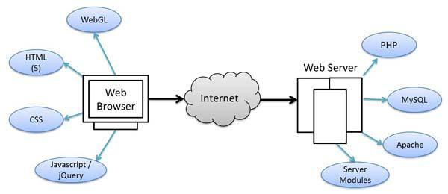

**Figure: Typical diagram of a website**

6

**2.1.1 HTML:**

HTML or Hyper Text Markup Language is the standard markup language used to create web pages. HTML is the set of markup symbols or codes inserted in a file intended for display on a World Wide Web (WWW) browser page. The markup tells the web browser how to display a web page’s words and images for the user.

The basic form of a HTML page is like following……

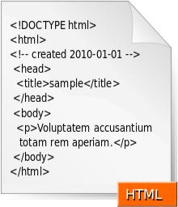

**Figure: Typical diagram of a website**

**2.1.2 CSS:**

CSS stand for Cascading Style Sheet. Web Designers that don't use CSS for their design and development of web sites are rapidly becoming a thing of the past. And it is arguably as important to understand CSS as it is to know HTML - and some would say it was more important to know CSS style sheet refers to the document itself. Style sheets have been used for document design for years. Cascade is the special part. A Web style sheet is intended to cascade through a series of style sheets, like a river over a waterfall.

CSS is one of the most powerful tools

7

* A Web designer can learn because with it you can affect the entire mood and tone of a Web site.
* Well written style sheets can be updated quickly and allow sites to change what is prioritized or valued without any changes to the underlying XHTML.
* It saves time. When most of us first learn HTML, I get taught to set the font face, size, color, style etc. every time it occurs on a page. This means I find my selves typing (or copying & pasting) the same thing over and over again. With CSS, you only have to specify these details once for any element.
* CSS will automatically apply the specified styles whenever that element occurs.
* It makes Pages to load faster less code means faster download times.
* It’s Easy to maintain. To change the style of an element, you only have to make an edit in one place.

**2.1.3 Bootstrap 4:**

**Bootstrap 4** is the newest version of **Bootstrap**, which is the most popular HTML, CSS, and JavaScript framework **for** developing responsive, mobile-first websites.

**2.1.4 jQuery:**

jQuery stands from JavaScript Query which is a powerful framework of JavaScript. The purpose of jQuery is to make it much easier to use JavaScript on website. jQuery is a

lightweight, "write less, do more", and JavaScript library. The purpose of J query is to make it much easier to use java’s website. jQuery takes a lot of common tasks that require many lines of JavaScript code to accomplish, and wraps them into methods that you can call with a single line of code. jQuery also simplifies a lot of the complicated things from JavaScript, like AJAX calls and DOM manipulation.

8

The jQuery library contains the following features:

* HTML/DOM manipulation
* CSS manipulation
* HTML event methods
* Effects and animations
* Utilities

**2.1.5 PHP:**

PHP stands for Preprocessor Hypertext which is a server site is scripting language mainly used for communicating with server. It is also widely-used open source general-purpose scripting language that is especially suited for web development and can be embedded into HTML.

PHP code is interpreted by a web server with a PHP processor module, which generates the resulting web page: PHP commands can be embedded directly into an HTML source document rather than calling an external file to process data. It has also evolved to include a command-line interface capability and can be used in one graphical application.

9(A)

**2.1.6 MYSQL:**

MySQL is an [open source](http://www.webopedia.com/TERM/O/open_source.html) RDBMS that relies on SQL for processing the data in the [database.](http://www.webopedia.com/TERM/D/database.html) MySQL provides [APIs](http://www.webopedia.com/TERM/A/API.html) for the languages [C,](http://www.webopedia.com/TERM/C/c.html) [C++,](http://www.webopedia.com/TERM/C/C_plus_plus.html) [Eiffel,](http://www.webopedia.com/TERM/E/Eiffel.html) [Java,](http://www.webopedia.com/TERM/J/Java.html)  [Python.](http://www.webopedia.com/TERM/P/Python.html) In addition, [OLE](http://www.webopedia.com/TERM/O/OLE.html) DB and [ODBC](http://www.webopedia.com/TERM/O/ODBC.html) providers exist for MySQL data connection in the Microsoft environment. A mysql.NET Native Provider is also available, which allows native MySQL to [.NET](http://www.webopedia.com/TERM/D/dot_NET.html) access without the need for OLE DB.

My SQL is most commonly used for Web [applications](http://www.webopedia.com/TERM/A/application.html) and for embedded applications and has become a popular alternative to [proprietary](http://www.webopedia.com/TERM/P/Proprietary.html) database systems because of its speed and reliability. MySQL can run on [UNIX,](http://www.webopedia.com/TERM/U/UNIX.html) [Windows](http://www.webopedia.com/TERM/M/Microsoft_Windows.html) and [Mac OS.](http://www.webopedia.com/TERM/M/Mac_OS.html)

9(B)

MySQL is developed, supported and marketed by MySQL AB. The database is available for free under the terms of the [GNU](http://www.webopedia.com/TERM/G/GNU.html) General Public License (GPL) or for a fee to those who do not wish to be bound by the terms of the GPL.

MySQL does the following terms:

* MySQL is a database system used on the web
* MySQL is a database system that runs on a server
* MySQL is ideal for both small and large applications
* MySQL is very fast, reliable, and easy to use
* MySQL supports standard SQL
* MySQL compiles on a number of platforms
* MySQL is free to download and use
* MySQL is developed, distributed, and supported by Oracle Corporation

10

**2.1.7 Wamp :**

Wamp, Apache, MySQL, PHP, Perl” and is a “solution stack package” that installs each of those items (don’t you just love techno-jargon?). Similarly there exists a WAMP, MAMP, and LAMP, standing for Windows, Mac, and Linux, respectively. I believe they condense the “P” to PHP/Perl/Python because Python is additionally included in the stack, whereas it’s not in Wamp.

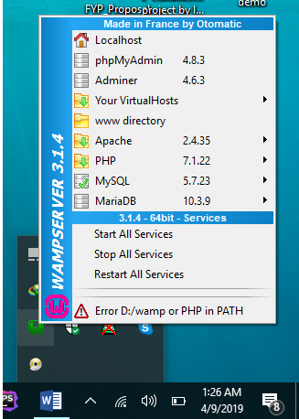

**Figure: User view of Wamp control center**

In general, Wamp is used for web development on your local machine, as opposed to directly on your web space. It allows you to tinker and test out changes on your personal computer before making those changes publicly online. The Wamp package is simply an easy way to install all the vital web server parts all at once, though it’s just as possible to install them all individually and by hand instead. Some people prefer to do that for a better understanding of the individual setup for each piece of software. If you prefer to focus on web development, though, Wamp should be perfectly acceptable.

11

**2.2 Methodology:**

Various inconsistencies and mismanagement of several **Online Car Portal** are detected after the case study and my findings. By analyzing the finding and the demand of people of several categories I have tried to remove those inconsistencies and security hazard in my system. Based on my findings and report I will implement the following functionalities to ablate the drawbacks of existing system.

**2.2.1 Developing the crucial functionalities:**

This will include the development and fertilize the administration part of my project which will include add admin, edit admin, buy books and so on.

12

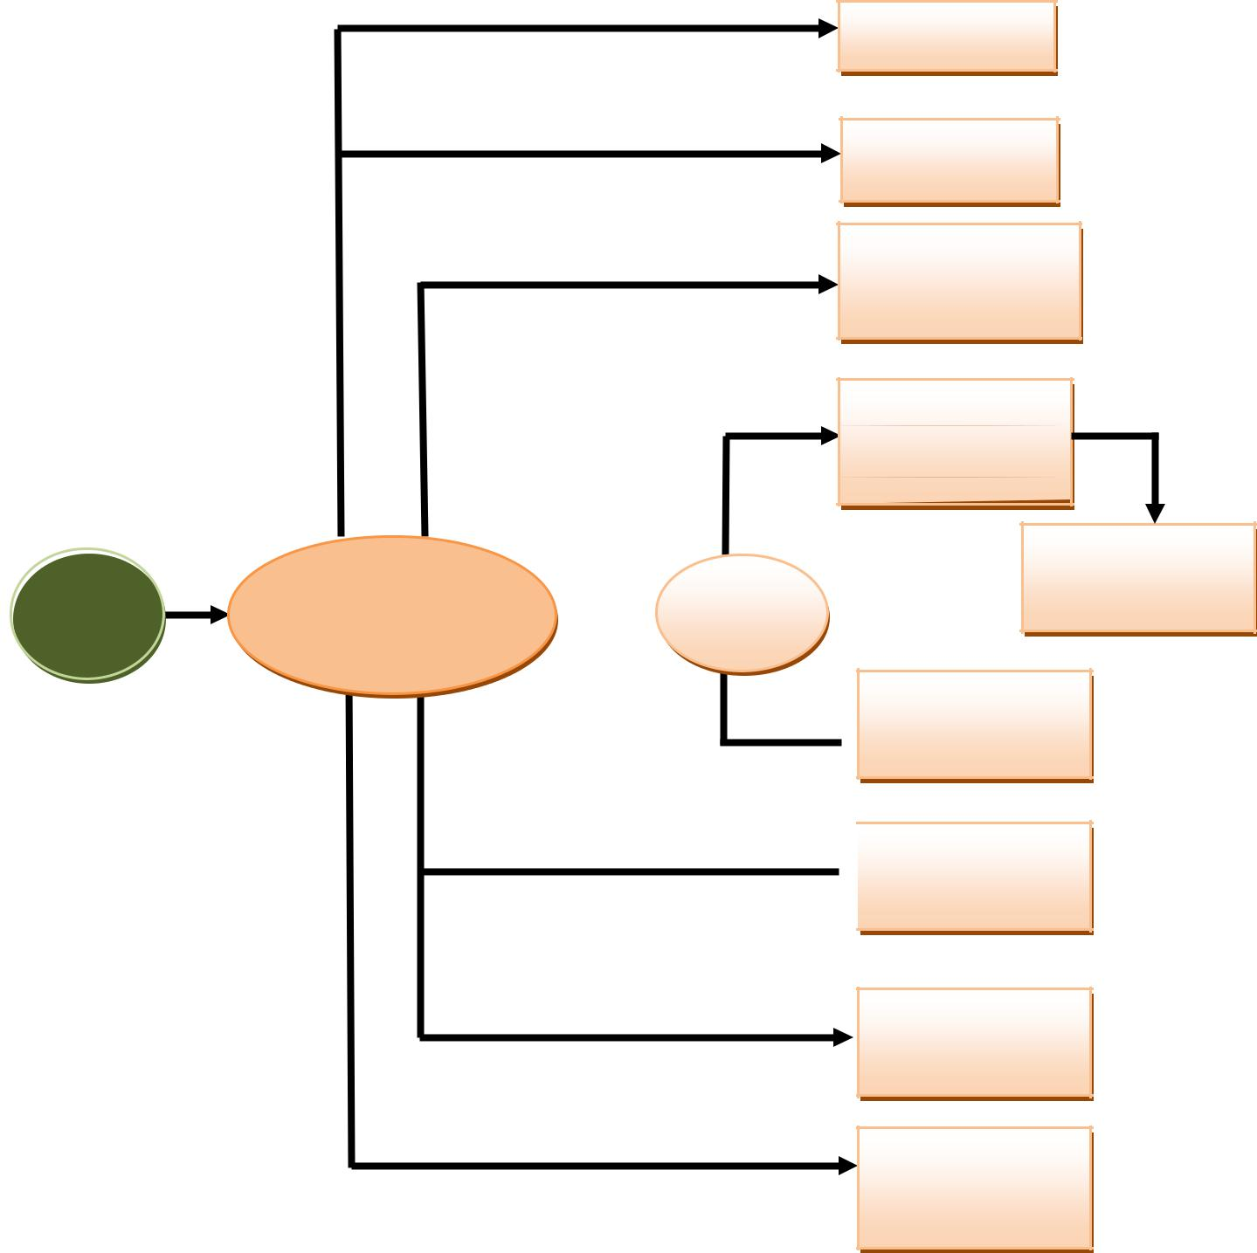

**Register**

**Browse**

**Add item to**

**shopping**

**Handle**

**shopping**

|  |  |  |  |
| --- | --- | --- | --- |
|  | Visit online | Cars |  |
| **User** | **Login** |  |
| Cars Portal |  |
|  |  |  |

**Update**

 **account info**

 **User review**

**Logout**

**Forget**

**password**

**Figure: Customer user case diagram**

13

**2.2.2 Facilitating the user for allowing them access in the system:**

In my next phase I will develop the panel for user so that this will enable them to choose category anytime from anywhere with detail information .This functionality will be a major one because most of the user wants to know every detail of the books and order details.

**2.2.3 Developing the report generation and analytical functionalities:**

Sometimes it is boring to search for information of any books. In the system as the chronological information are not stored in one place. So, to get rid of this monotonous task, I will develop functionality for my system that will generate a search option from where a user can search for books like for her / him.

**2.2.4 Use of waterfall method:**

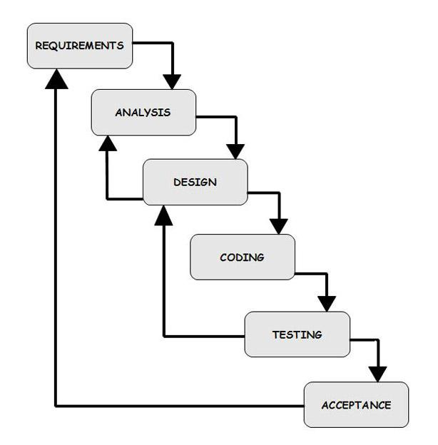

The methodology I will use to develop the **OTBMS** is waterfall model. Waterfall model is one of the system development life cycle (SDLC) models. Users proceed to next phase

14

if and only if current phase is complete. Users are not allowed to go back to previous phases if there is any mistake so the model is named after **waterfall** model.

In Royce’s original waterfall model, the waterfall model originally consists of **seven** **phases** which are ___

* Requirement specification
* Design
* Construction
* Integration
* Testing
* Debugging
* Installation and
* Maintenance

**Requirement Analysis and Definition:**

All possible requirements of the system to be developed are stated in this phase. Requirements are a set of functions and constraints that the end user expects from the system. The requirements are gathered from the end user, and are analyzed for their validity and the possibility of incorporating them. Finally, a requirement specification document is created which serves the purpose of a guideline for the next phase of the model.

**System and Software Design:**

Before starting the actual coding phase, it is highly important to understand the requirements of the end user and also have an idea of how the end product should look like. The requirement specifications from the first phase are studied here, and a system design is prepared. The design helps in specifying hardware and system requirements,

15

And also helps in defining the overall system architecture. The system design specifications serve as an input for the next phase of the model.

**Implementation and Unit Testing**:

On receiving system design documents, the work is divided in modules/units and actual coding starts. The system is first elaborated into small programs called units, which are integrated in the next phase. Each unit is developed and tested for its functionality; this is referred to as unit testing. Unit testing mainly verifies if the modules/units meet their specifications.

**Integration and System Testing:**

The units are now integrated to form a complete system during the integration phase and tested to check if all modules/units coordinate with each other and the system as a whole behaves as per the specifications. After successfully testing the software, it is delivered to the user.

**Installation and Deployment:**

The software is now applied by the user to his/her own system(s). What the user’s needs to take care of is his system complying with the minimum system requirements of the software. He also needs to take care of any system configurations and reconfigurations on his side of the deal. Once the software is properly installed, he will begin communication with the dealers on a need-to-know basis, and help report any bugs that occur.

**Operations & Maintenance:**

This phase of the model is virtually never-ending. Generally, problems with the system (which are not found during the development cycle) come up after its practical use starts, so the issues related to the system are solved after its deployment. Not all the problems come into picture directly, but they arise from time to time and need to be solved; hence this process is referred.

16

## Adopted Methodology

Incremental model is used to develop this project, in which we divided our work in multiple modules. All these modules are further divided into more easily managed modules which made up the actual implementation of the requirements.

Reason behind using this model is:

* It is easy to test and debug the product during iterations.
* Software released in increments over time is more likely to satisfy changing user requirements than if it were planned as a single overall release at the end of the same period.
* Generates working software quickly and early during the software life cycle.
* This model is more flexible – less costly to change scope and requirements.
* It is easier to test and debug during a smaller iteration.
* In this model customer can respond to each built.
* Lowers initial delivery cost.
* Easier to manage risk because risky pieces are identified and handled during it’d iteration.

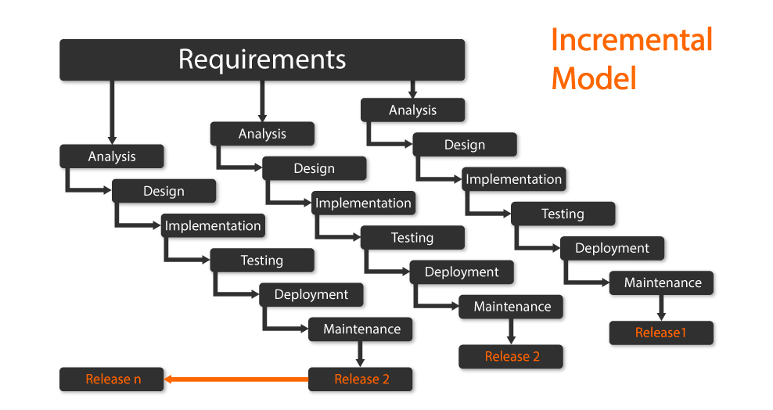

Figure : Adopted Methodology

16A

**CHAPTER 3**

**SYSTEM ANALYSIS**

**Systems analysis** is the study of sets of interacting entities. According to the Merriam-Webster dictionary, systems analysis is "the process of studying a procedure in order to identify its goals and purposes and create systems and procedures that will achieve them in an efficient way". Analysis and synthesis, as scientific methods, always go hand in hand; they complement one another. Every synthesis is built upon the results of a preceding analysis, and every analysis requires a subsequent synthesis in order to verify and correct its results.

**3.1 Schema:**

Pronounce *skee-ma,* the structure of a database system, described in a formal language supported by the database management system (DBMS). In a relational database, the schema defines the tables, the fields in each table, and the relationships between fields and tables.

Schemas are generally stored in a data dictionary. Although a schema is defined in text database language, the term is often used to refer to a graphical depiction of the database structure.

**3.2 Primary Key:**

A primary key, also called a primary keyword, is a key in a relational database that is unique for each record.

**3.3 Foreign Key:**

A foreign key is a column or group of columns in a relational database table that provides a link between data in two tables. It acts as a cross-reference between tables because it references the primary key of another table, thereby establishing a link between them.

17

**3.4 Data Dictionary:**

A data dictionary is a collection of descriptions of the data objects or items in a data model for the benefit of programmers and others who need to refer to them. A first step in analyzing a system of object with which users interact is to identify each object and its relationship to other objects. This process is called data modeling and results in a picture of object relationships. After each data object or item is given a descriptive name, its relationship is described (or it becomes part of some structure that implicitly describes relationship), the type of data (such as text or image or binary value) is described, possible predefined values are listed, and a brief textual description is provided. This collection can be organized for reference into a book called a data dictionary.

* In order to manage the details in large-scale systems.
* Most systems are ongoing and dynamic and management of all the descriptive details is difficult, therefore an accurate and consistent recording technique is essential.
* To communicate a common meaning for all of the elements in the system.
* Simply making sure that for all elements, the meaning will remain consistent.
* To document features of the system.
* It is essential to document the circumstances under which data items occur.
* To locate errors and omissions in the system.
* The data dictionary may reveal information that is incomplete and/or inaccurate. It may show stores that are never accessed and/or processes that should be sub-divided, etc.

18

**3.5 Description of data objects in database table:-**

**Table 1: Table Structure of users**

|  |  |  |  |  |  |  |
| --- | --- | --- | --- | --- | --- | --- |
| **Field** | **Type** | **Null** | **Key** | | **Description** | |
|  |  |  |  |  |  |  |
| **id** | Int | No | Primary key |  | User id |  |
|  |  |  |  |  |  |  |
| **name** | Varchar (30) | No |  |  | User name |  |
|  |  |  |  |  |  |  |
| **email** | Varchar (100) | No |  |  | User Email Id |  |
| **Phone Number** | Varcher(225) | Yes |  |  | User Phone Number |  |
|  |  |  |  |  |  |  |
| **Password** | Varchar (255) |  |  |  | User password |  |
|  |  |  |  |  |  |  |
| **Phone No** | int (30) | No |  |  | User Phone Number |  |
|  |  |  |  |  |  |  |
| **created at** | Timestamp | No |  |  | User Upload data |  |
|  |  |  |  |  |  |  |
| **Updated at** | Timestamp | No |  |  | Admin update Data |  |
|  |  |  |  |  |  |  |

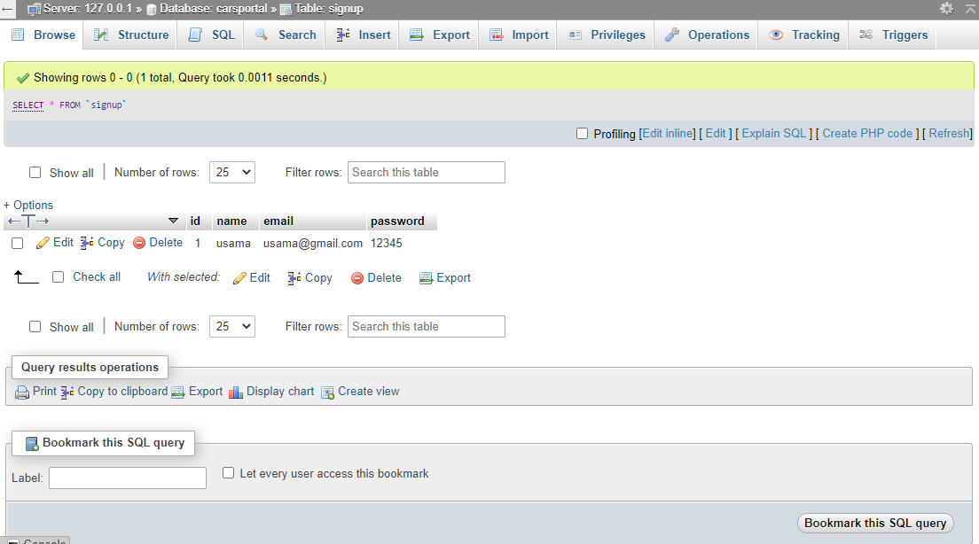

19

**Table 2: Table structure of cars**

|  |  |  |  |  |
| --- | --- | --- | --- | --- |
| Field | Type | Null |  | **Key** |
|  |  |  |  |  |
| ID | Int | No |  | Primary |
|  |  |  |  |  |
| **Car** Title | varchar(50) | No |  |  |
|  |  |  |  |  |
| **Car** Overview | varchar(250) | No |  |  |
|  |  |  |  |  |
| **Car Brand** | Varchar(50) | No |  |  |
|  |  |  |  |  |
| **Car Type** | varchar(50) | No |  |  |
|  |  |  |  |  |
| **Car** Image | varchar(50) | No |  |  |
|  |  |  |  |  |
| **Car** Price | Int | Yes |  |  |
|  |  |  |  |  |
| **Car** Models | varchar(50) | No |  |  |
|  |  |  |  |  |
| created at | Timestamp | No |  |  |
|  |  |  |  |  |
| Update at | Timestamp | No |  |  |
|  |  |  |  |  |

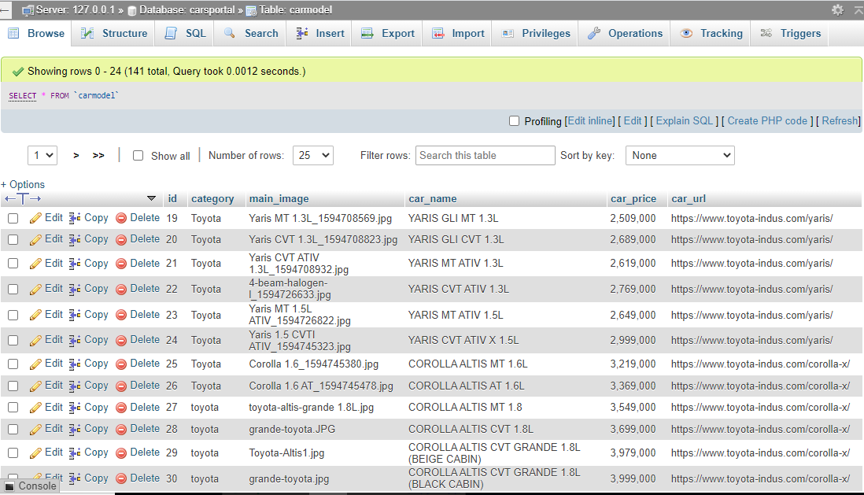

20

**Table 6: Table Structure of cars Items**

|  |  |  |  |  |  |
| --- | --- | --- | --- | --- | --- |
| **Field** | **Type** | | **Null** | **Key** | **Description** |
|  |  |  |  |  |  |
| Id | Int |  | No | Primary key | Id |
|  |  |  |  |  |  |
| User Email | Int |  | No |  | User Email |
|  |  |  |  |  |  |
| Vehicel id | int(50) |  | No |  | Vehicel id |
|  |  |  |  |  |  |
| From Date | Int |  | No |  | From Booking |
|  |  |  |  |  |  |
| End Date | Int |  | No |  | To Booking |
|  |  |  |  |  |  |
|  |  |  |  |  |  |
|  |  |  |  |  |  |
|  |  |  |  |  |  |
| Massage | Varchar(50) |  | Yes |  | Massage for Booking |

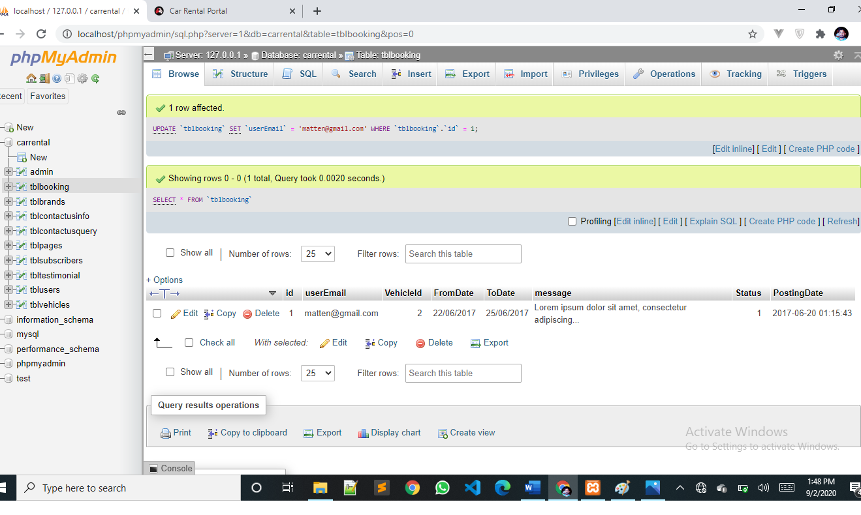

21

**Table 7: Table Structure of Slider Table**

|  |  |  |  |  |  |  |
| --- | --- | --- | --- | --- | --- | --- |
| **Field** | | **Type** | **Null** |  | **Key** | **Description** |
|  |  |  |  |  |  |  |
| id |  | Int | No |  | Primary key | id |
|  |  |  |  |  |  |  |
| Image |  | Varchar | No |  |  | name |
|  |  |  |  |  |  |  |
|  |  |  |  |  |  |  |
|  |  |  |  |  |  |  |
|  |  |  |  |  |  |  |
|  |  |  |  |  | |  |

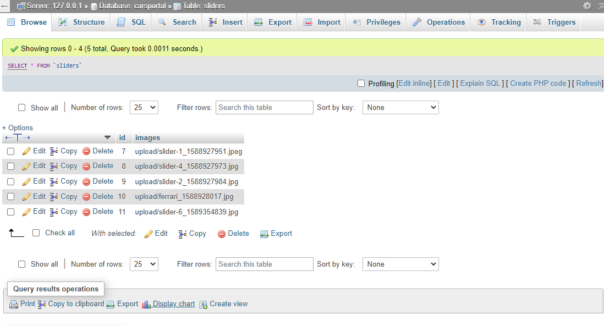

22

**Table 8: Table Structure of Admin**

|  |  |  |  |  |  |  |
| --- | --- | --- | --- | --- | --- | --- |
| **Field** | | **Type** | **Null** | **Key** | **Description** |  |
|  |  |  |  |  |  |  |
| id |  | Int | No | Primary key | id |  |
|  |  |  |  |  |  |  |
| Name |  | Varchar(50) | No |  | name |  |
|  |  |  |  |  |  |  |
| Email |  | Varchar(100) | No |  | Email |  |
|  |  |  |  |  |  |  |
| password | | Varchar(150) | No |  | Password |  |
|  |  |  |
|  |  |  |  |  |  |
|  |  |  |  |  |  |  |
| Created at |  | Varchar(50) | No |  | Date |  |
|  |  |  |  |  |  |  |

23

**Admin Table:**

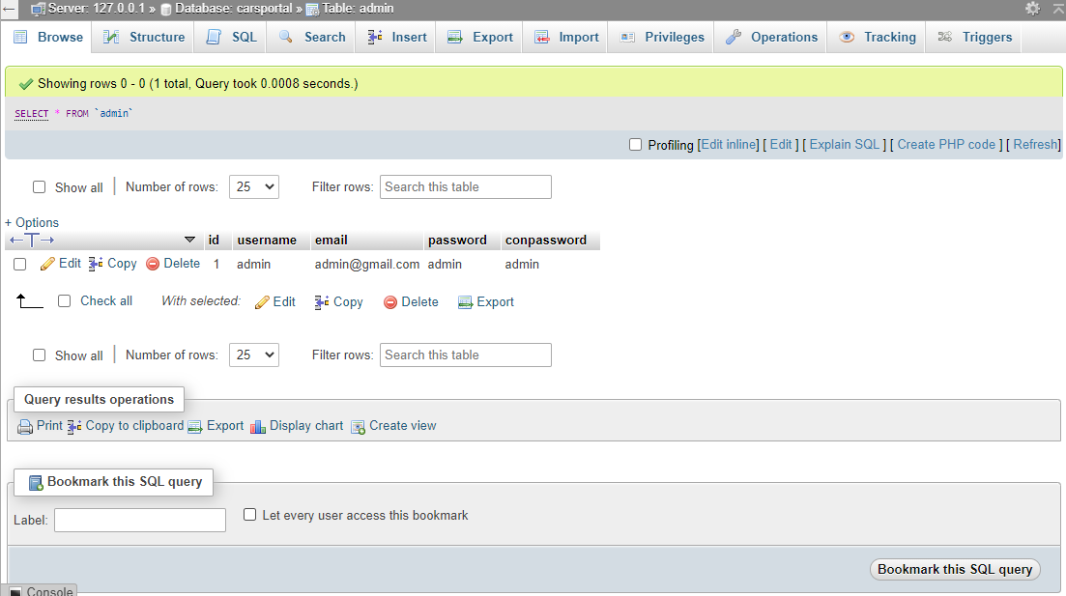

24

**3.6 Entity Relationship Diagram (E-R diagram):**

An entity-relationship (ER) diagram is a specialized graphic that illustrates there relationships between entities in a database. ER diagrams often use symbols to represent three different types of information. Boxes are commonly used to represent entities. Diamonds are normally used to represent relationships and ovals are used to represent attributes.

**3.6.3 ER diagram**

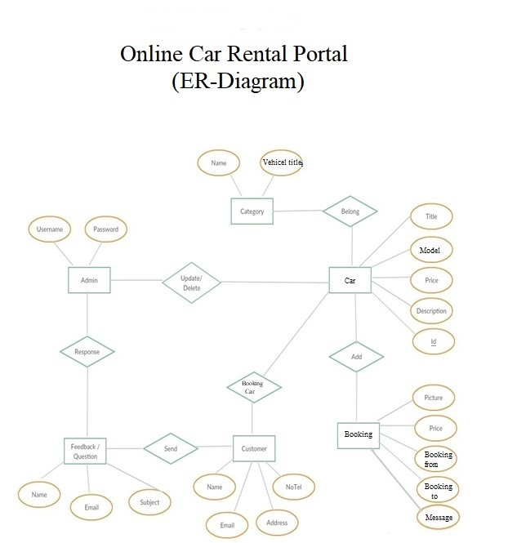

25

***3.7 Use Case***

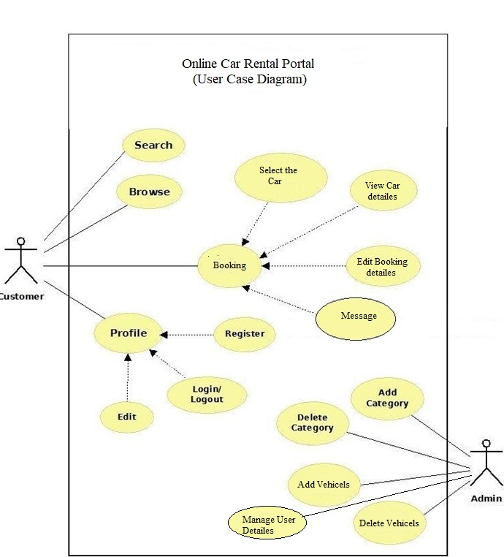

26

26

***3.8 Sequence Diagram :***

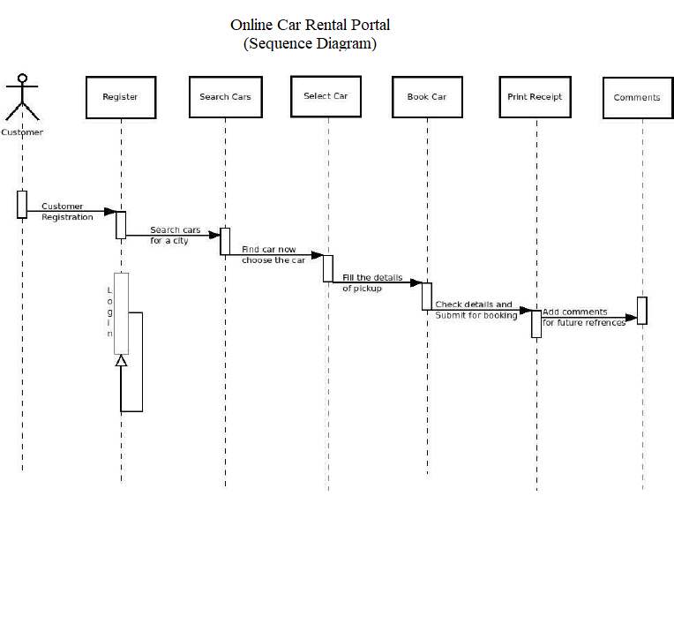

***`*** 27

***3.9 Class Diagram :***

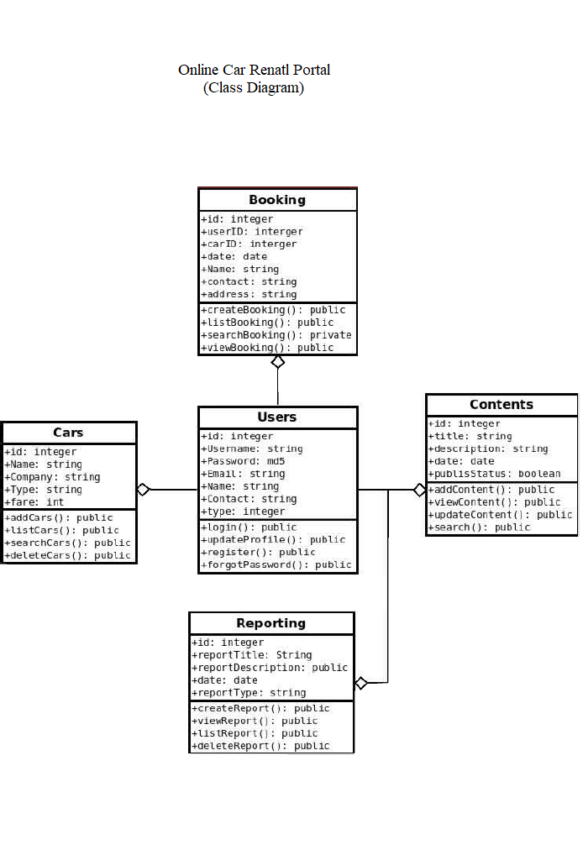

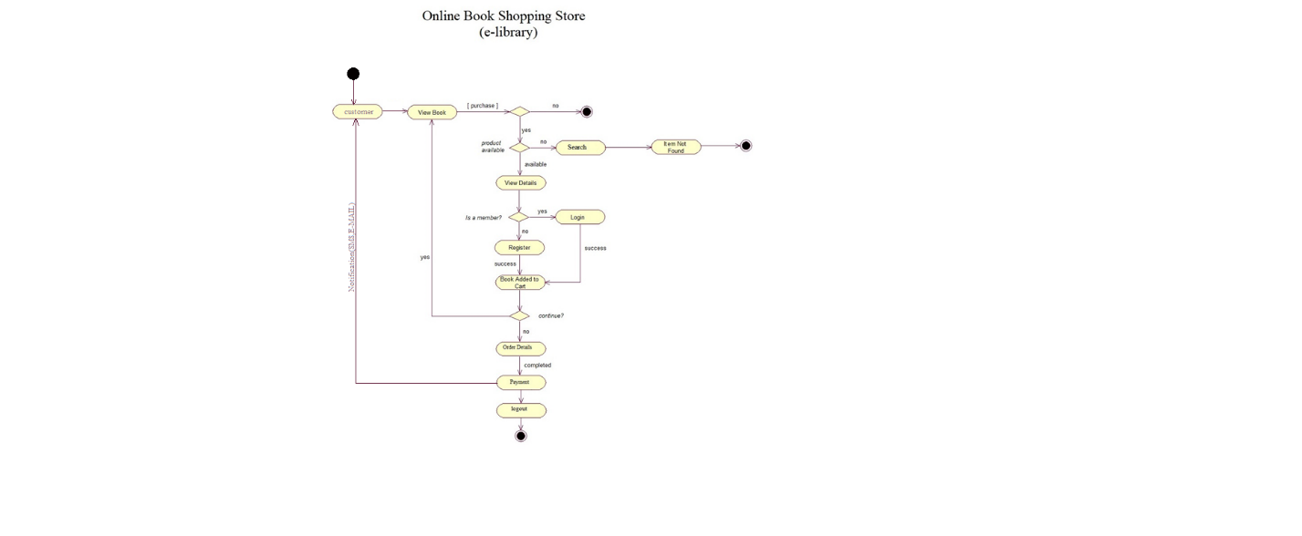

28

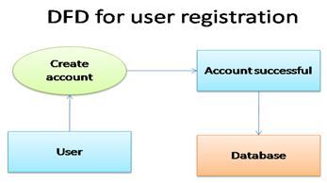

**3.10 DFD For user view**

Here the information regarding by user review about the special cars. All users can read cars view but only registered users can write reviews. All the information is stored in this database.

**DFD for Book review**

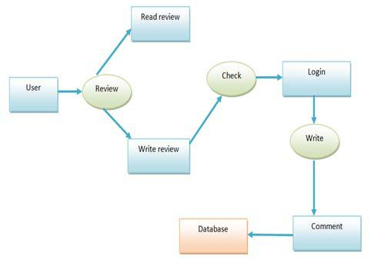

29

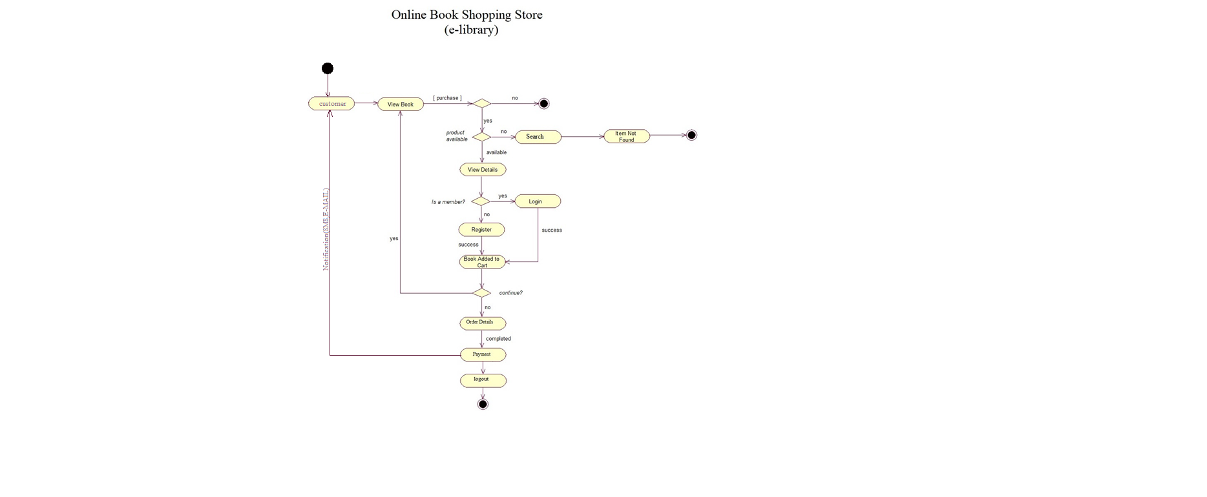**3.11 DFD for Online Car Portal :**

The users search the available Car and then the Car. There are three options to complete Booking: Booking cart, update account info and then fulfill payment. Then the order details is shown to user invoice & stored in database.

**DFD for Booking Cars**

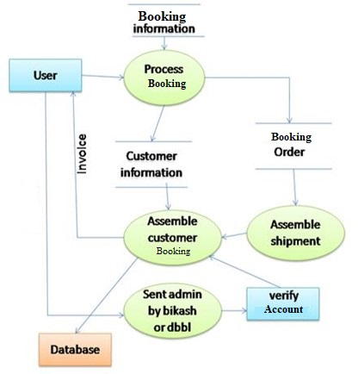

30

## Planning & Scheduling

### Gantt chart

A Gantt chart is a scheduling technique that is used commonly in project management. It is one of the useful and common ways of representation of activities displayed in contrast to time. On the vertical side of the chart activities list is displayed and on the top a time scale which is appropriate. A bar represents each activity’s length and also shows the start date, end date and duration of the activity. This shows following information.

* “What the different activities are?”
* “When an activity starts and ends?”
* “How much long each activity is scheduled to finish?”
* “The start and finish date of the whole project.”

**Key Milestones of the Project with dates**

**Table** Error! No text of specified style in document.**‑1: Project Plan & Key Milestones**

|  |  |  |  |
| --- | --- | --- | --- |
| **Key Milestones of the Project with dates** | | | |
| **S. No** | **Elapsed time since start of the project** | **Milestone** | **Deliverable** |
| 1. | 1 Month (September 11,2019- October 11,2019) | Analysis & Requirements | Complete Research Proposal |
| 2. | 1 Month (October 12,2019 -November 18,2019) | Planning, scheduling and purchase of hardware | Report |
| 3. | 1 month (November 19,2019-december 9,2019) | Modeling & design | Report |
| 4. | 2 month (December 10,2019-  February 10,2020) | Coding & testing | Software System |
| 5. | April 15,2020 | Deployment | Hardware & Software System |

31

**CHAPTER 4**

**TESTING**

This chapter describes to develop a test plan for the Online cars design system. This document defines all the procedures and activities required to prepare for testing of the functionalities of the system which are specified in Vision document. The objectives of the test plan are to define the activities to perform testing, define the test deliverables documents and to identify the various risks and contingencies involved in testing.

**4.1 Featured to be tested**

The following list describes the features to be tested:

**USER:**

* Registration
* Login
* View cars
* Search Cars

**ADMIN:**

* Create and Delete Car from Category
* Create and Delete a Category
* Manage Car
* Manage Members

32

***4.2 Test cases***

***4.2.1 User Registration***

|  |  |  |  |  |  |  |  |  |  |
| --- | --- | --- | --- | --- | --- | --- | --- | --- | --- |
| **ID** | | **Test case** |  | **User input** |  |  | **Pass Criteria** | |  |
|  |  |  |  |  |  |  |  |  |  |
| U_reg_1 |  | User |  | User selects already | Display message to | | |  |  |
|  |  | Registration |  | existing Email address. | choose different email address | | |  |  |
|  |  |  |  |  |  |  |  |  |  |
| U_reg_2 |  | User |  | User enters different | Display message that Password | | | |  |
|  |  | Registration |  | password in password | and Confirm Password fields | | | |  |
|  |  |  |  | confirm field | don't Match | | | |  |
|  |  |  |  |  |  |  |  |  |  |
| U_reg_3 |  | User |  | User forgets to enter a | Display message The | | |  |  |
|  |  | Registration |  | particular required fields | value in field is | | |  |  |
|  |  |  |  |  | required | | |  |  |
|  |  |  |  |  |  |  |  |  |  |
| U_reg_4 |  | User |  | User enters all the details | User account created | | |  |  |
|  |  | Registration |  | successfully |  |  |  |  |  |
|  |  |  |  |  |  |  |  |  |  |
| ***Login*** | |  |  |  |  |  |  |  |  |
|  | |  |  |  |  |  |  |  |  |
| **ID** | | **Test case** |  | **User input** |  |  | **Pass Criteria** |  |
|  |  |  |  |  |  |  |  |  |  |
| U_log_1 |  | User login |  | User enters wrong email |  |  | Display message to |  |  |
|  |  |  |  | address |  |  | Login or wrong email |  |  |
|  |  |  |  |  | |  |  |  |  |
| U_log_2 |  | User login |  | User enter wrong password | |  | Display message to |  |  |
|  |  |  |  |  |  |  | message or wrong |  |  |
|  |  |  |  |  |  |  | password |  |  |
|  |  |  |  |  |  |  |  |  |  |
| U_log_3 |  | User login |  | User enters correct email |  |  | User logs in successfully |  |  |
|  |  |  |  | address and password |  |  |  |  |  |
|  |  |  |  |  |  |  |  |  |  |
|  |  |  |  | |  |  |  |  |  |

33

***Cars***

|  |  |  |  |  |  |  |  |  |  |  |
| --- | --- | --- | --- | --- | --- | --- | --- | --- | --- | --- |
| **ID** | **Test case** |  |  | **User input** | |  |  | **Pass Criteria** | |  |
|  |  |  |  |  |  |  |  |  |  |  |
| U_car _1 | cars |  |  | Users select a vehicle |  |  |  | Cars/Vehicle is added to |  |  |
|  |  | and click add to car |  |  |  | car |  |  |
|  |  |  |  |  |  |  |  |  |
|  |  |  |  |  |  |  |  |  |  |  |
| U_car _2 | cars |  |  | Guest selects a car | |  |  | User should create an |  |  |
|  |  | and click add to car | |  |  |  |  |
|  |  |  |  |  |  | account |  |  |
|  |  |  |  |  |  |  |  |  |  |
|  |  |  |  |  |  |  |  |  |  |  |
| ***Edit cars:*** |  |  |  |  |  |  |  |  |  |  |
| **ID** | **Test case** |  |  | **User input** | |  |  | **Pass Criteria** | |  |
|  |  |  |  |  | |  |  |  | |  |
| U_EB_1 | Edit cars |  |  | User changes the |  |  |  | Change the Date |  |  |
|  |  | Date |  |  |  |  |  |  |
|  |  |  |  |  |  |  |  |  |
|  |  |  |  |  |  |  |  |  |  |  |
|  |  |  |  |  | |  |  |  |  |  |
|  |  |  |  | Users select a new | |  |  | Change the Exaction |  |  |
| U_EB_3 | Edit car |  |  |  |  |  |  |  |
|  |  | car to cart | |  |  |  |  |
|  |  |  |  |  |  |  |  |  |  |  |

34

***4.2.2 Admin***

***Create edit and delete a Car:***

|  |  |  |  |  |  |  |  |  |
| --- | --- | --- | --- | --- | --- | --- | --- | --- |
| **ID** |  | **Test case** | |  | **User input** |  | **Pass Criteria** |  |
|  |  |  |  |  |  |  |  |  |
|  |  | Create edit and |  |  | Admin creates a new |  | Book should be Created |  |
| A_Car_1 |  | delete a Car |  |  |  |  |
|  |  |  | Car |  | in the car list |  |
|  |  |  |  |  |  |  |
|  |  |  |  |  |  |  |  |  |
|  |  | Create edit and |  |  | Admin edits an |  | Car should be updated |  |
| A_Car_1 |  | delete a Car |  |  |  |  |
|  |  |  | available Car |  | in the Car list |  |
|  |  |  |  |  |  |  |
|  |  |  |  |  |  |  |  |  |
|  |  | Create edit and |  |  |  |  | Cars should be updated |  |
| A_Car_1 |  | delete a Car |  |  | Admin deletes a Car |  |  |
|  |  |  |  | in the Car list |  |
|  |  |  |  |  |  |  |  |  |
| ***Create edit and delete a category:*** | | | |  |  |  |  |  |
|  |  |  | |  |  |  |  |  |
| **ID** |  | **Test case** | |  | **User input** |  | **Pass Criteria** |  |
|  |  |  | |  |  |  |  |  |
|  |  | Create edit and |  |  | Admin creates a new |  | Cars should be updated |  |
| A_cat_1 |  | delete a category |  |  |  |  |
|  |  |  | Category |  | in the category. |  |
|  |  |  |  |  |  |  |
|  |  |  |  |  |  |  |  |  |
|  |  | Create edit and |  |  | Admin edits a |  | Cars should be updated |  |
| A_cat_1 |  | delete a category |  |  |  |  |
|  |  |  | Category |  | in the category. |  |
|  |  |  |  |  |  |  |
|  |  |  |  |  |  |  |  |  |
|  |  | Create edit and |  |  | Admin deletes |  | Cars should be updated |  |
| A_cat_1 |  | delete a category |  |  |  |  |
|  |  |  | Category |  | in the category. |  |
|  |  |  |  |  |  |  |
|  |  |  |  |  |  |  |  |  |
|  |  |  |  | 35 | |  |  |  |

***Manage Slider:***

|  |  |  |  |  |  |  |  |  |
| --- | --- | --- | --- | --- | --- | --- | --- | --- |
| ID | Test case |  |  | User input | |  | Pass Criteria |  |
|  |  |  |  |  |  |  |  |  |
| A_mb_1 | Manage slider |  |  | Admin accepts an |  |  | Slider is processed |  |
|  |  |  | slider |  |  |  |
|  |  |  |  |  |  |  |  |
|  |  |  |  |  |  |  |  |  |
| A_mb_1 | Manage slider |  |  | Admin detects an |  |  | Slider is not processed |  |
|  |  |  | Confirm |  |  |  |
|  |  |  |  |  |  |  |  |
|  |  |  |  |  |  |  |  |  |
| ***Manage Users:*** |  |  |  |  |  |  |  |  |
|  |  |  |  |  | |  |  |  |
| ID | Test case |  |  | User input | |  | Pass Criteria |  |
|  |  |  |  |  | |  |  |  |
| A_mu_1 | Manage users. |  |  | Admin accepts |  |  | Member is accepted |  |
|  |  |  | members |  |  |  |
|  |  |  |  |  |  |  |  |
|  |  |  |  |  |  |  |  |  |
| A_mu_1 | Manage users. |  |  | Admin detects |  |  | Member is not accepted |  |
|  |  |  | members |  |  |  |
|  |  |  |  |  |  |  |  |
|  |  |  |  |  |  |  |  |  |

36

**4.3 Approach**

This section describes the overall approach of the testing which ensures that the each feature and the combination of the features are adequately tested. The major tasks that are used are

**Unit testing:**

Unit testing is a method of testing that verifies the individual units of source code are working properly. The goal of unit testing is to isolate each part of the program and show that the individual parts are correct

**Load testing:**

Load testing is the process of creating demand on a system or device and measuring its response. It generally refers to the practice of modeling the expected usage of a software program by simulating multiple users accessing the program concurrently. As such, this testing is most relevant for multi-user systems; often one built using a client/server model, such as web servers

**System Testing:**

Once the entire system has been built then it has to be tested against the Software Requirement Specification and System Specification to check if it delivers the features required. System testing can involve a number of specialist types of test to see if all the functional and non-functional requirements have been met.

**Performance Testing**

The system should meet the performance requirements as mentioned in the document. The performance will be evaluated based on the response time of the GUI and the database commands.

37

**Manual Testing**

Manual Testing will be done to ensure the correctness of various parts of the code using test cases generated by the tester.

**4.4 Pass/fail criteria**

The system should satisfy all the functional requirements, in the document. Each feature to be tested will be evaluated against its requirement as stated in the Vision Document. The pass or fail of a test depends on whether the system meets with all the particular post conditions. Test cases executed on the Online Cars will pass if they meet the specific requirements as mentioned in the Documentation.

**CHAPTER 5**

**GRAPHICAL USER INTERFACE**

This chapter will show the Graphical User Interface (GUI) of the system through screenshots and user guides that how will they operate the system.

**5.1.1 Home *Page* :**

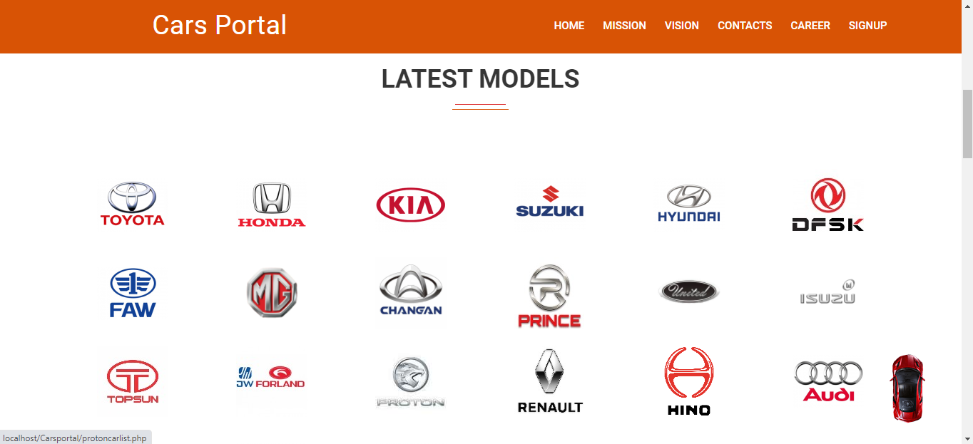

39

***5.1.2 Registering Users:***

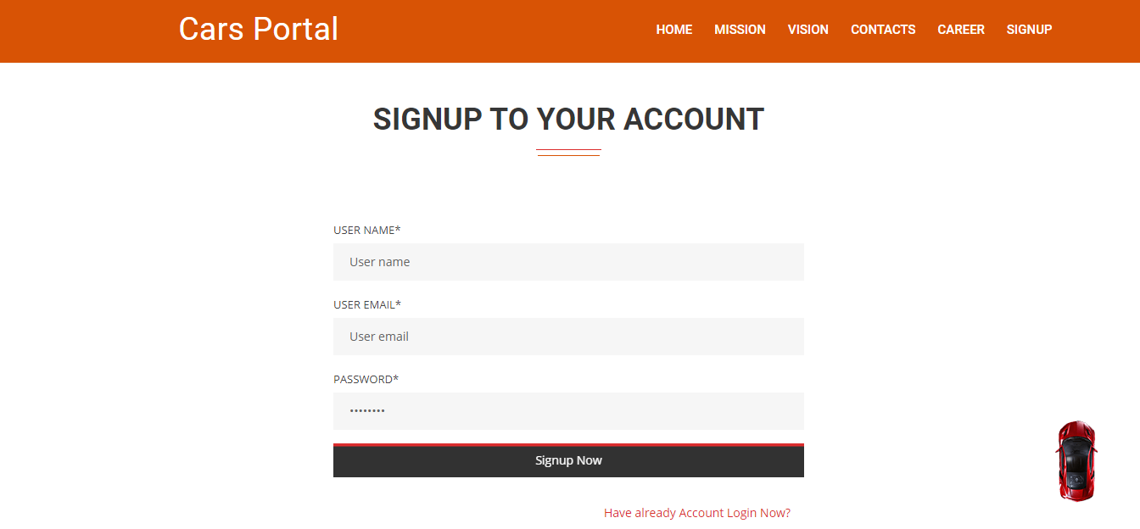

***5.1.3 Car details and user’s view***

40

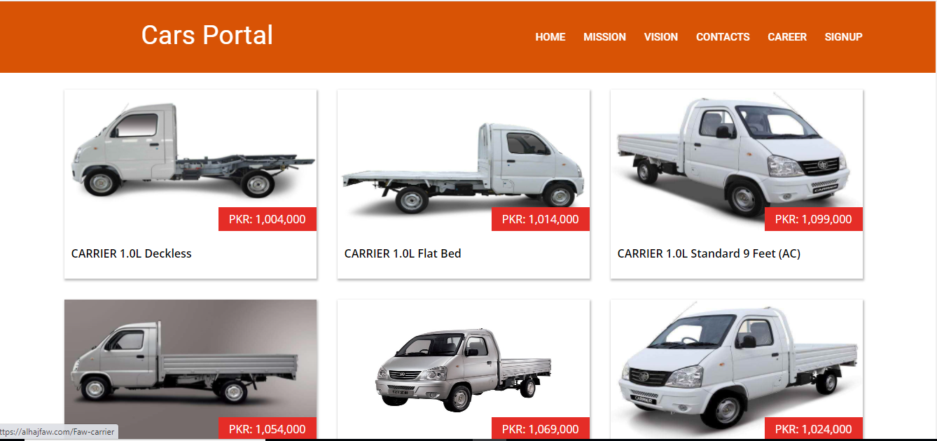

***5.1.4 Car Detailes***

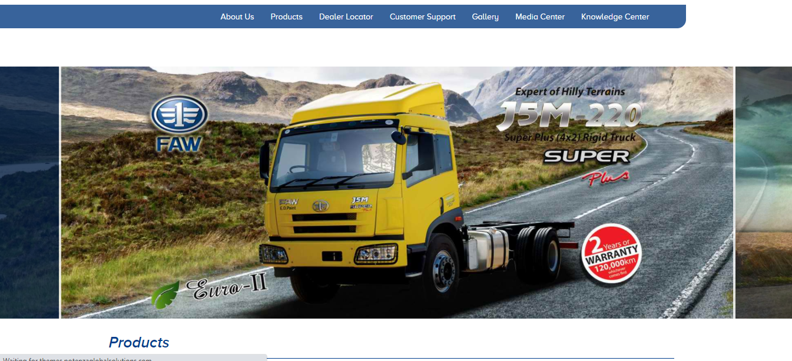 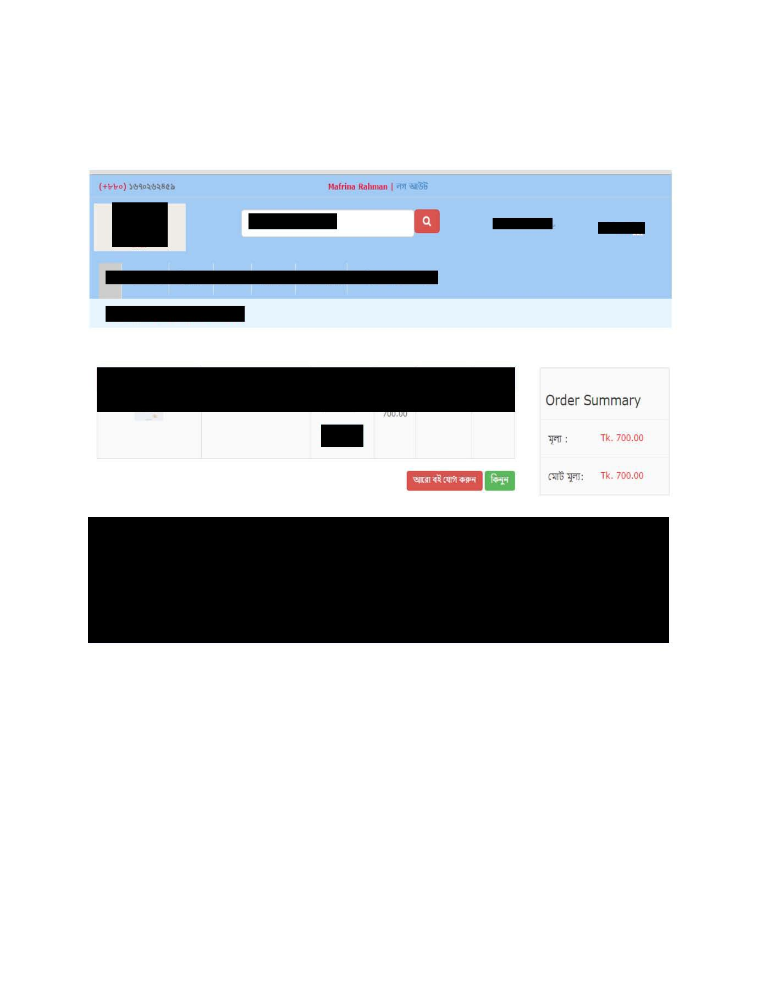

41

***5.1.5 Services***

***5.1.5.1Car Services***

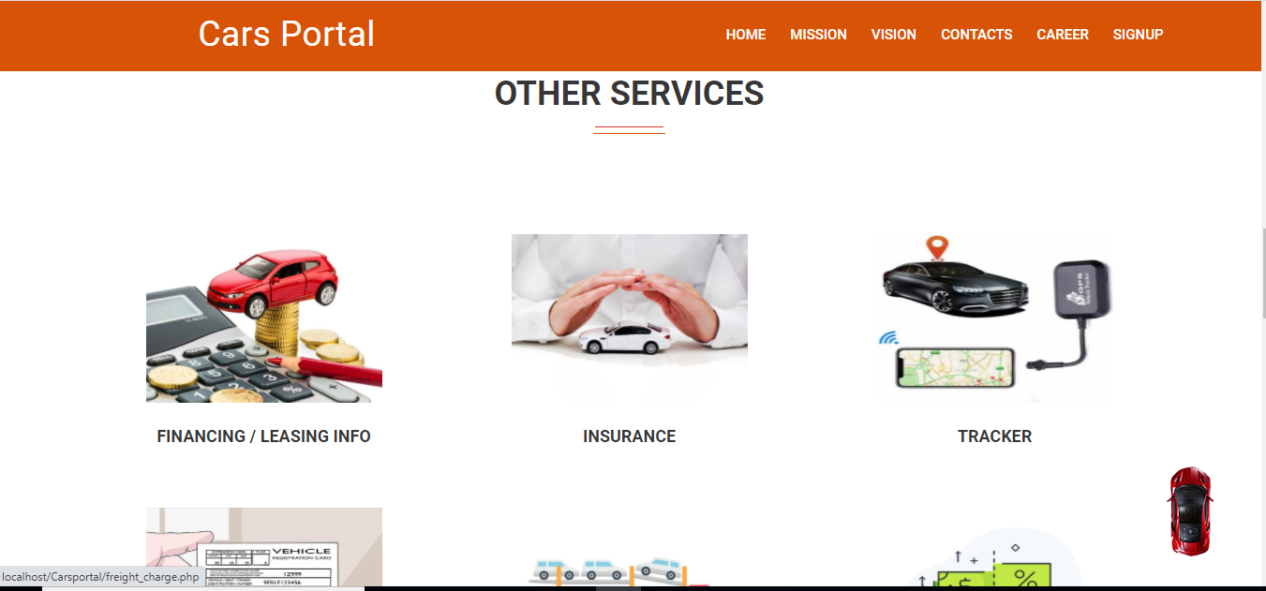

42

***5.1.5.2 Suzuki Cars***

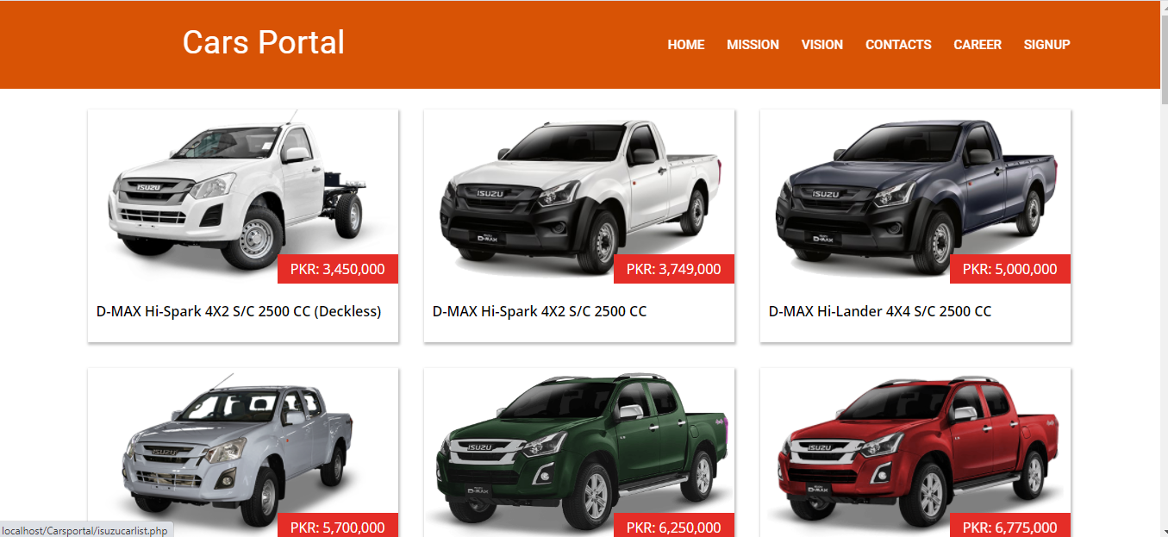

***5.1.5.3 Login***

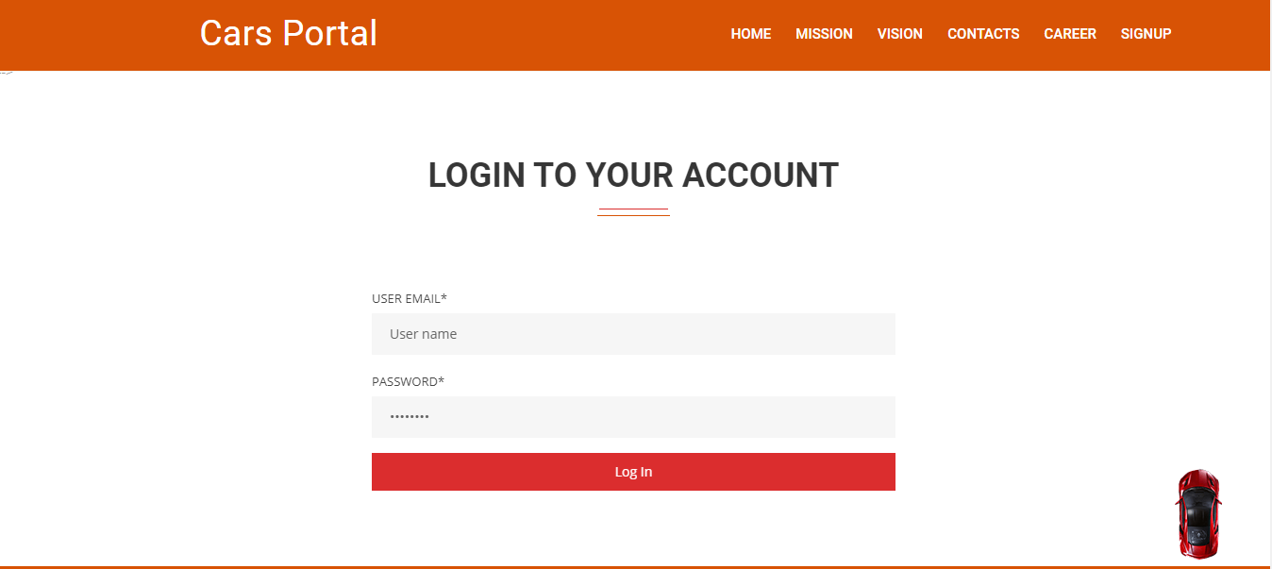

43

***5.1.7 Contact of user:***

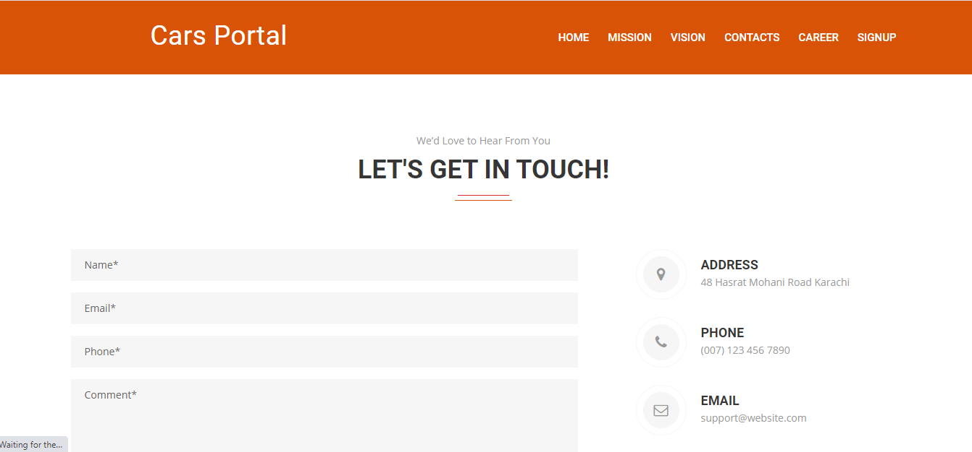

44

***5.2 Admin login page***

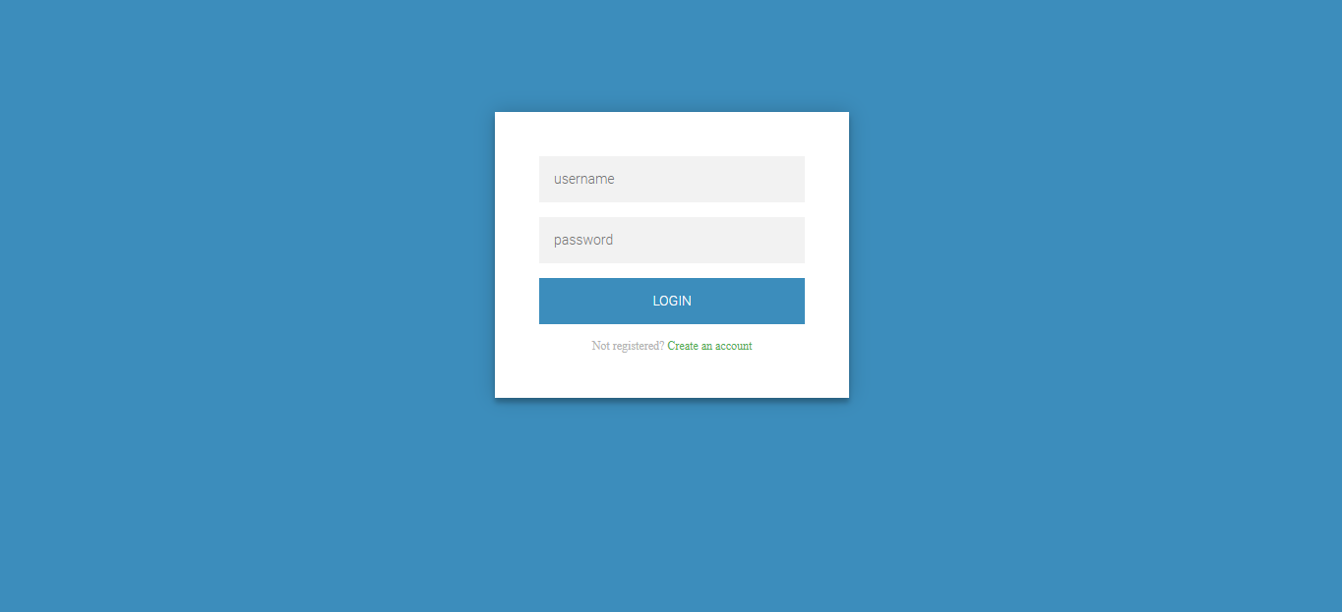

***5.2.1 Admin home page***

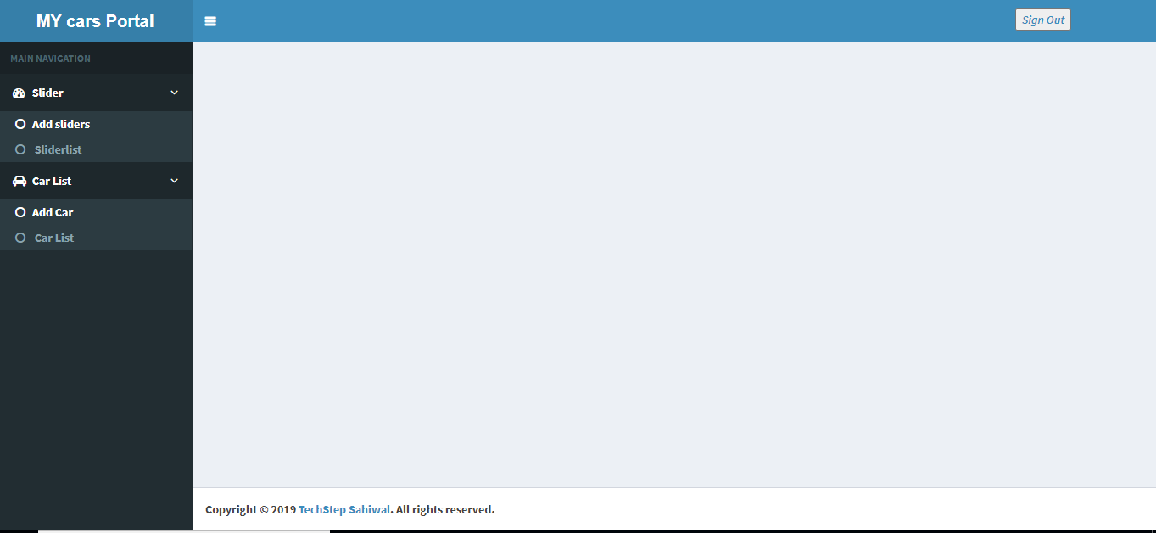

45

***5.2.2: Manage Cars***

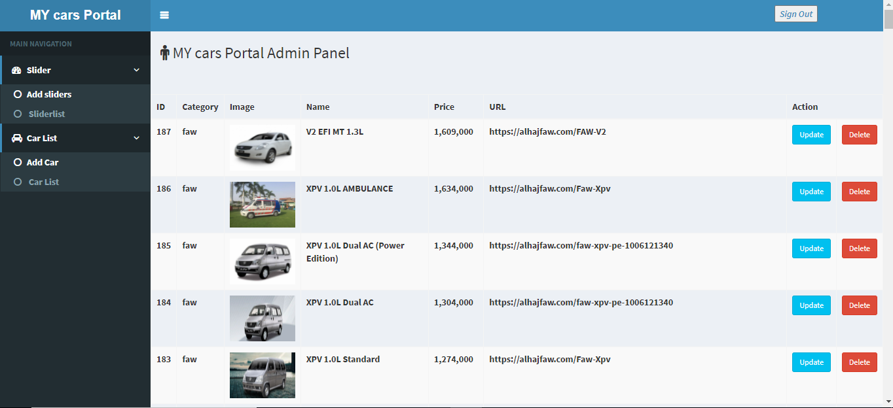

46

**CHAPTER 6**

**CONCLUTION**

**6.1 Limitation of the system:**

Though I have tried my level best to make my system flawless and user friendly by using the modern technologies, some minor functional and design inconsistencies exist in my system due to time constraint, design of prototype and cost constraints. The limitations of “Online Car Portal is:

* I have used Ajax in my system which will show the system after loading fully. Though it is faster, it may cause malfunction in hasty situation. That is, incomplete loading of the system.
* In this system no transaction is added, so users can not show any transaction details.
* Users can not add Car in his/her Car list.

**6.2 Prospective future improvement:**

My system websites developed based on current findings, demand of users satisfaction and facilities. In my system I have used the modern web technologies to make my system fast, convenient and efficient for all of the personnel mentioned. Due to time and cost constraint it was not possible to fulfill all requirements and functionalities those were planned. But in future these planned functionalities and more improvement will be possible to pursue. The functionalities to be implemented are:

* I will try to keep a function so that any user can add cars in his/her wish list.
* Car rating system will be added.
* Add SMS Notification ( Registration , Login).
* If any new feature like, any where of user access in our the world.

47

**6.3 Conclusion:**

The purpose of the website is to create an Online Cars that allows users to search cars online based on category. I hope this will satisfy the demand of the user and the user can find all available cars and details of the cars to purchase without any time and energy waste.

This website is totally dynamic and extendable.

If the website needs to extend then I must have to work little on the database. So, I have the demand to develop a website that considers all the issues. Keeping all these things in mind I have tried my best to build a website which is secure, dynamic, extendable and reusable. There still have the opportunity to add other features that are not mentioned here.

Some minor functional problem may occur during operation, but it will not have any minimum effect on kernel part of the system.

48

**References**

**Websites:**

1. <http://www.networksolutions.com/education/what-is-Portal> /
2. http://www.mysql.com/
3. http://www.w3schools.com/
4. <http://stackoverflow.com/>
5. https://www.pakwheels.com/

49